**MIS 273 – Lab 6 Failover Clustering Install**

**Part 1 – Install the Failover Clustering Feature**

1. Read Chapter 13 on Implementing Failover Clustering before continuing.
2. Use your Windows Server Domain Controller to do the 11 steps called “Install the Failover Clustering Feature” listed in chapter 13 or on slides 16 and 17 of the chapter 13 PowerPoint slides.
3. Reboot your Windows Server after installing the Failover Clustering feature.
4. After rebooting go to the Tools menu of Server Manager and choose the Failover Cluster Manager. To show you’ve done part 1, take a screen shot of the Failover Cluster Manage window and paste it below.

Paste a screen-shot of the Failover Cluster Manage window here:

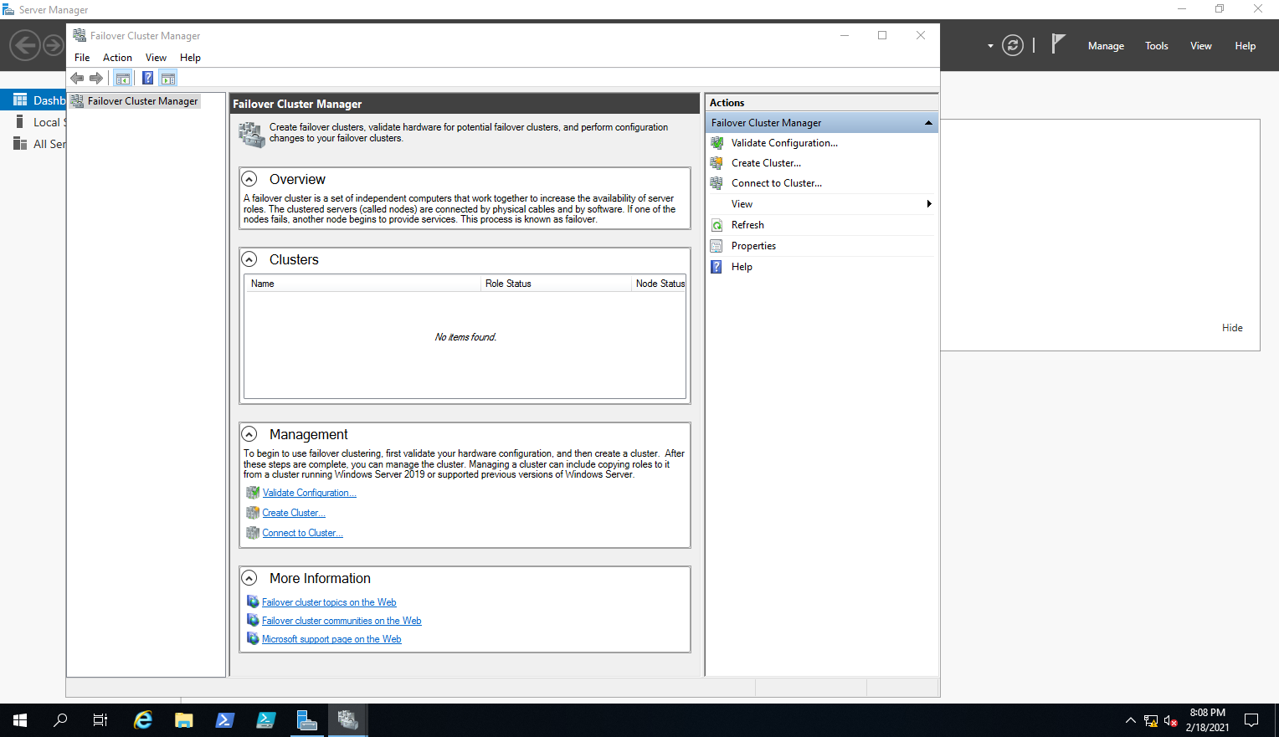

**Part 2 – Validate Cluster Configuration**

1. Use the same Windows Server to do the 10 steps called “Validate Cluster Configuration” listed in chapter 13 or on slides 18 and 19 of the chapter 13 PowerPoint slides. When you get to step 5 rather than typing the name of your server, click the Browse button. Select the Advanced button and the Find Now button. The names of all the computers in the domain should show up. (It may be that only your domain controller shows since none of the other labs have required you to add another computer to your domain.) Select your domain controller and click OK. At that point continue with step 6 to run all the tests. Note: To complete the validation you only need to add your domain controller since we have not added any other servers to the domain.
2. To show you’ve done part 2, take a screen shot of the Summary page and paste it below.

Paste a screen-shot of the Summary Page in the Validate a Configuration Wizard here:

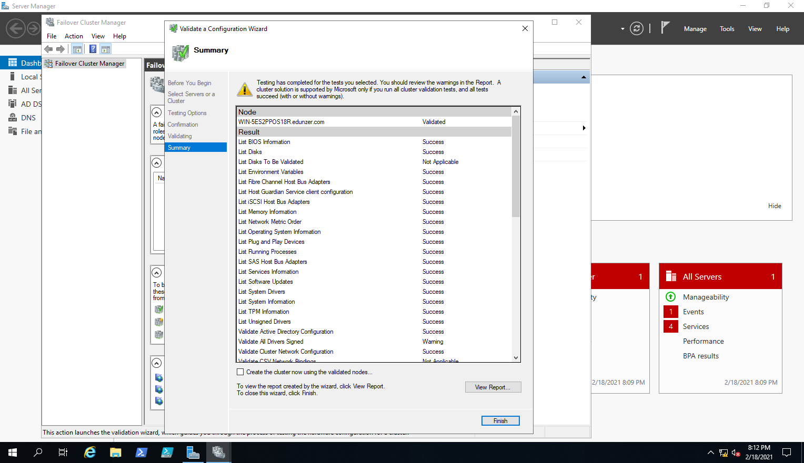

**Part 3 – Create a Cluster**

1. Use the same Windows Server to do the 6 steps called “Create a Cluster” listed in chapter 13 or on slides 20 and 21 of the chapter 13 PowerPoint slides. When you get to step 3 rather than typing the name of your server, click the Browse button. Select the Advanced button and the Find Now button. The names of all the computers in the domain should show up. (It may be that only your domain controller shows since none of the other labs have required you to add another computer to your domain.) Select your domain controller and click OK. At that point continue with step 4 to add a cluster name. Note: To complete the validation you only need to add your domain controller since we have not added any other servers to the domain. Of course this means that you haven’t created a true cluster if there is only one server in the cluster. However you’ve seen the steps required to create the cluster which is the goal of this lab.
2. To show you’ve done part 3, take a screen shot of the Access Point for Administering the Cluster page or the Confirmation page (either page will do) and paste it below.

Paste the screen-shot here:

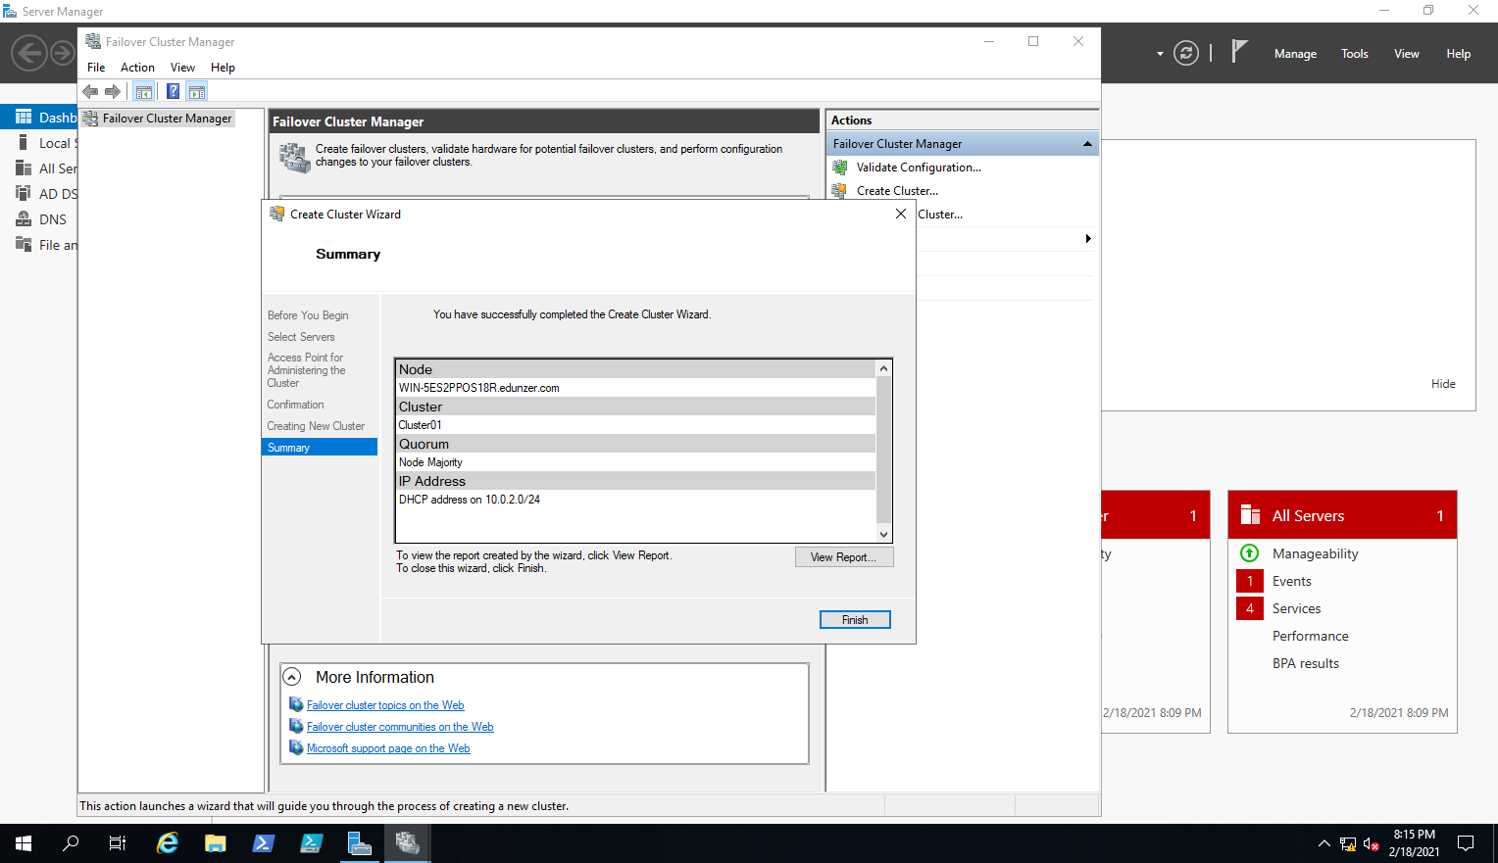

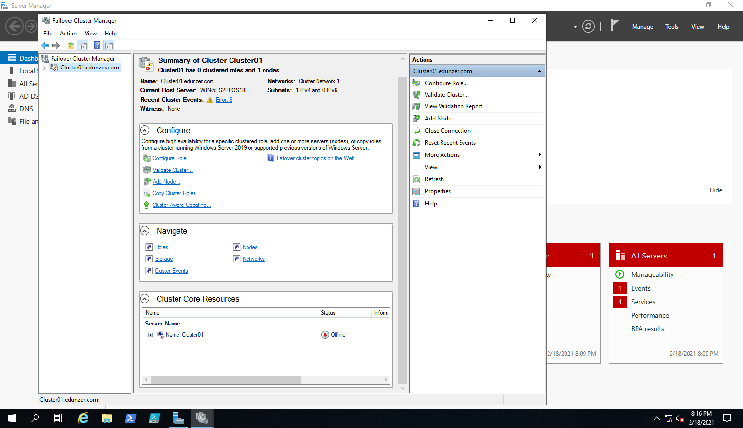

Upload this document to Canvas using the appropriate link.